**Project Write Up : Project 4, Group 11**

**Video Game Sales**

Tyler Beringer, Jason Johnson, Brian Marowsky, Noah Stevens

**Introduction and Purpose**

For this project, we wanted to explore trends in sales reviews in regards to video game sales. Through the use of multiple data sets on video game sales and reviews ranging from 1980 to 2016 which contained trends of market sales per million units, as well as critic user reviews. We were able to evaluate trends throughout the years and find correlations and relationships between different values. With this data in hand, we were able to use our machine learning model to predict sales based on a number of inputs including platform and genre, better predicting which gaming platform and genre to look out for making future investments/interests.

The various aesthetics of our website and presentation reflect colors of a wide variety of gaming devices and platforms that can be found throughout our various data sets. With our data set being a high view composed of different platforms and models and not specific to one type or brand of gaming devices/genres,it was decided to incorporate mostly stock-type photos throughout our presentation and web application to better emphasize on the high level view that our data sets were presenting. Attached are links to both kaggle datasets we have used in the creation of our slide deck and web application.

Link to dataset #1:

<https://www.kaggle.com/datasets/rush4ratio/video-game-sales-with-ratings/data>

Link to dataset #2:

<https://www.kaggle.com/datasets/deepcontractor/top-video-games-19952021-metacritic>

**Data Cleaning**

With using 2 data sets, part of our initial data cleaning process was to combine both data sets into 1 table structure in order to evaluate both sets together. Once combined, we evaluated the data types to make sure all categories were listed as their correct data type. Next step was to replace instances of ‘tbd’(to be determined) and replace them with NaN ( Not a number). This in return allowed us to convert the column from a string to a float. With comparing both the df_reviews and df_games , each one had a “platform” column. While both columns shared a lot of the same video game consoles. The df_game’s column had their abbreviation instead of the full name like in df_reviews. To fix this, we converted the full names to their respective abbreviations which allowed for a cohesive, uniformed platform column. With this done, we were finally able to merge both sets of data on their shared columns of “name”,”platform” as shown below and then saved as our clean data set “game_final_clean”

Data columns (total 15 columns):

# Column Non-Null Count Dtype

--- ------ -------------- -----

0 name 16441 non-null object

1 platform 16441 non-null object

2 Year 16441 non-null int64

3 Genre 16441 non-null object

4 Publisher 16441 non-null object

5 NA 16441 non-null float64

6 EU 16441 non-null float64

7 JP 16441 non-null float64

8 Other 16441 non-null float64

9 Global 16441 non-null float64

10 Critic_Score 8299 non-null float64

11 Critic_Count 8007 non-null float64

12 User_Score 8863 non-null float64

13 Developer 9929 non-null object

14 Rating 9792 non-null object

dtypes: float64(8), int64(1), object(6)

memory usage: 2.0+ MB

Tableau- Sales Data

We divided our task between the comparison of User scores( Critics) and Sales data to categories such as platform, Genre. Our data from kaggle shared that the “global sales” was a sum of the 3 different regions from around the world , EU,NA,JP. This provided an opportunity to compare the different regions in regard to categories like Genre and platform. For Example, it was found that in Japan (JP) Role play games had the most units sold in millions compared to North America (NA) which preferred action games over roleplay games.

Japan

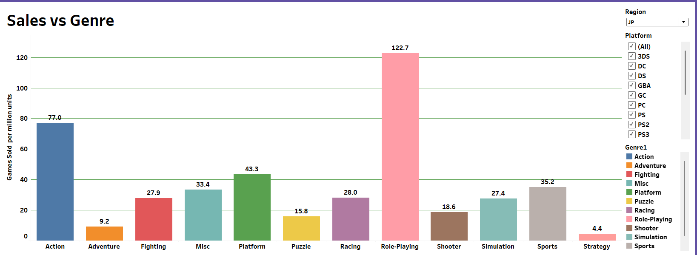

North America 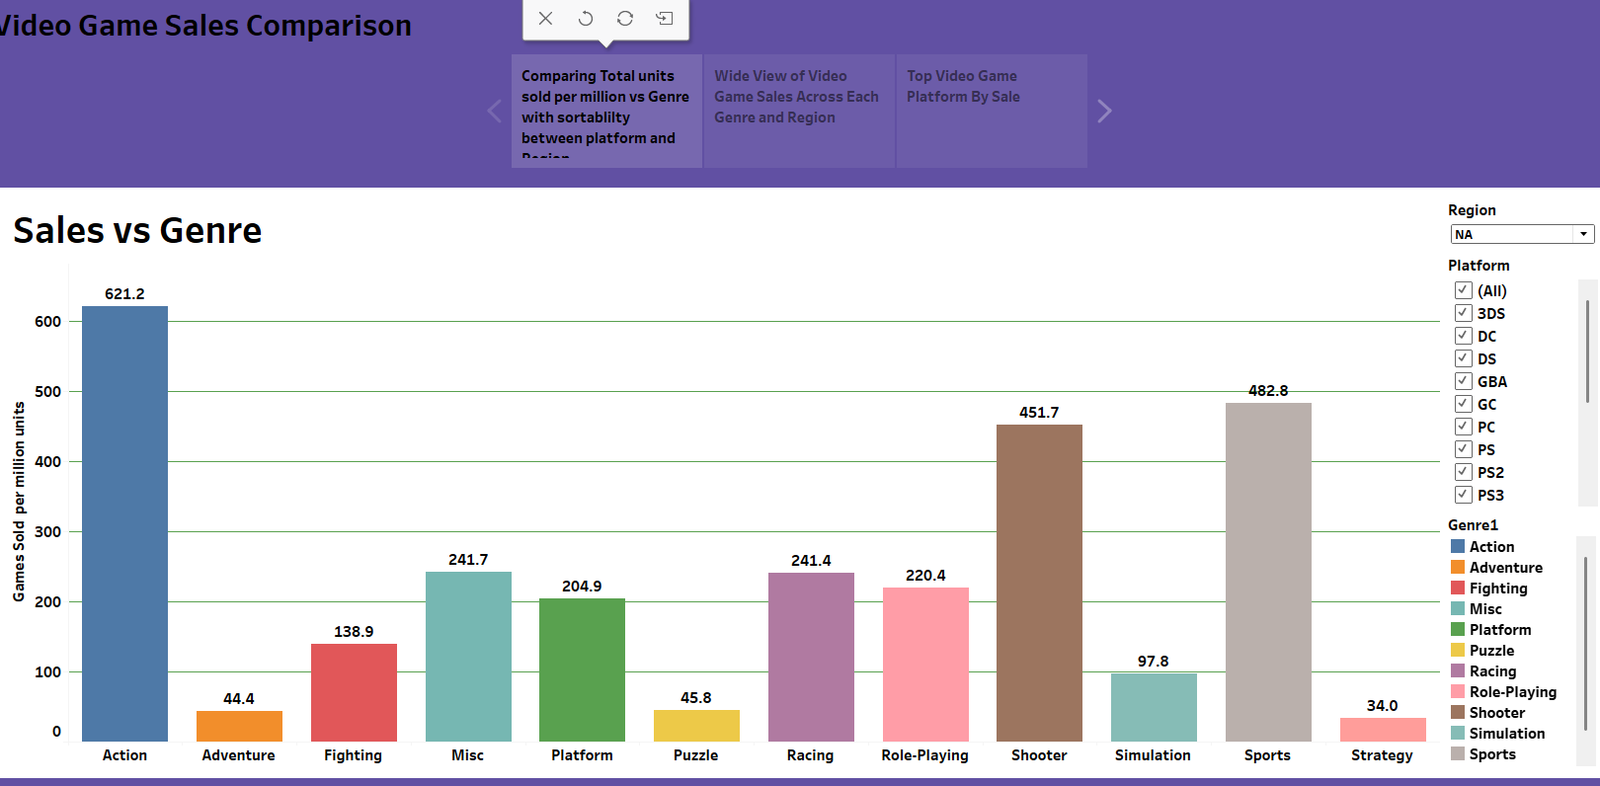

When looking at which video game platform had the most sales. Globally, PS2 was the winner overall while in North America, xbox 360 was on top.

North America Platform 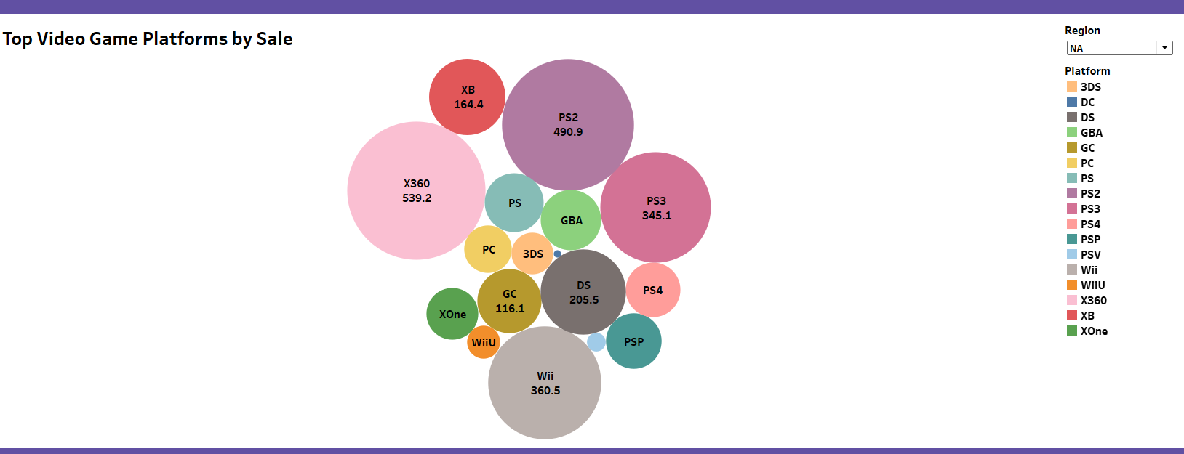

Global Platform

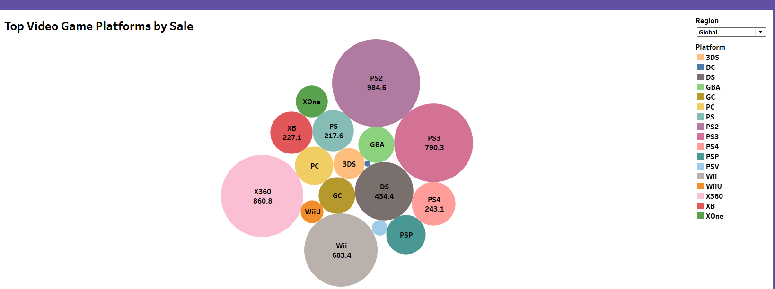

This information shared above would be most helpful in determining future prospects with sales not only globally but in their respective regional markets.

Tableau-Game Scores

Video games have been around since 1972. However, to give a bit of a back story, the very first video game was invented on October 18, 1958, by William Higinbotham which was titled "Tennis for Two.” This history making game was displayed on an oscilloscope and played with two custom aluminum controllers. The visuals would show a representation of a tennis court viewed from the side and the players adjust the angle of their shots with a knob on their controller and try to hit the ball over the net by pressing a button.

With this game being the pioneering start of one of the most popular indoor hobbies globally, evolution has taken over the video gaming experience to a point where there are scores and grades on the top video games that have been played. The only setback is the data only goes up to 2016 and not to the current date. Many have played the legendary titles mentioned here. For example, the most popular game with the highest Critic Score of 99/100 is “The Legend of Zelda Ocarina of Time” on the Nintendo 64 platform. In a three-way tie for 2nd with a Critic Score of 98/100 are: “Tony Hawk’s Pro Skater 2” for the PlayStation 1 platform, “Soul Calibur” for the Sega Dreamcast platform and “Grand Theft Auto IV” for the X-Box 360 and PlayStation 3 platforms.

Despite the popularity of the games mentioned above, the publishers of these great games must get the credit as well. With that being said, the number one publisher for this video game dataset is Electronic Arts with 1347 games. Some of the top titles are: FIFA 16 for PS4, FIFA Soccer 13 for PS3 and The Sims 3 for PC. In 2nd is Activision with notable titles such as: Call of Duty: Modern Warfare 3 for X360, Call of Duty: Black Ops 3 for PS4 and Call of Duty: Black Ops for X360 and in 3rd is Ubisoft with their “Just Dance” series 1-4 for the Nintendo Wii.

The popularity of video games has been widely regarded amongst gamers globally by Genre. In this dataset, there are 12 Genres listed from Action to Strategy. In the end, there are three that reign in the top 3. These Genres are: Action which is let by The Legend of Zelda: Ocarina of Time on the Nintendo 64 platform, Grand Theft Auto IV for the X360 & PS3 and Grand Theft Auto V for X360 & PS3. In 2nd is Sports with top titles such as: Tony Hawk’s Pro Skater 2 for PS1, Tony Hawk’s Pro Skater 3 for PS2 and NFL 2K1 for Sega Dreamcast. Finally, the 3rd Genre is Shooter leading the way is the legendary Halo: Combat Evolved for Xbox, Metroid Prime for Nintendo Game Cube and a three-way tie with BioShock for X360, Golden Eye 007, and The Orange Box for PC.

After analyzing the data for the gamer scores, the only issue that we as a group ran into is the null values for the older platforms such as Atari 2600, NES, Gameboy and Super Nintendo to name a few as they have null values for Critic Score and User Score.

Both pages were added to the application by using Java script attachments of the URL from the Tableau public website where both models were published.

<https://public.tableau.com/app/profile/jason.johnson3075/viz/VideoGameScores_17440655448690/Story1>

<https://public.tableau.com/app/profile/brian.marowsky/viz/Game_Sales_17440653955190/Story1>

Machine Learning model page

With our Data cleaned and prepared into one data set , we were able to begin work on our machine learning model. We ended up testing three models—Neural Network, Linear Regression, and Random Forest—to predict **Global Sales**. Performance was measured using the R² score, where **1 means perfect accuracy**. All models comfortably beat the goal of **0.80**, showing they’re strong predictors.

* **Neural Network**: R² = **0.96**
* **Linear Regression**: R² = **0.96**
* **Random Forest**: R² = **0.94**

The **Neural Network and Linear models performed slightly better** than the Random Forest, but overall, all three did a solid job predicting sales.

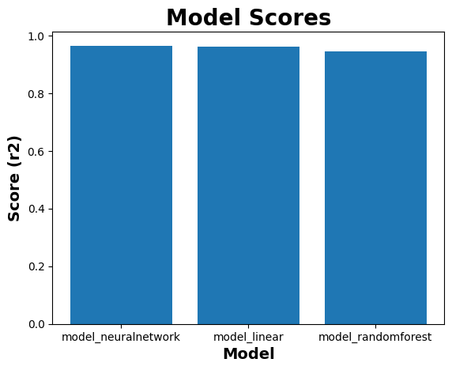

About us/ Work cited page /Report

Our about us page of our application included the information and picture of each group member who worked on the project. The Work Cited page includes any sources we used to create our project. Report page includes an embedded copy of this report.

Biases, limitations and Conclusion

When it comes to bias some limitations some aspects we notice when creating our data set were as follows the data sets very limited scope of the market in general the main attribute of the measure of sales being in per million units sold rather than actual dollar amounts of video games being sold another limitation is with the advent of modern day subscription platforms for video games Microsoft's Xbox game pass where measurement of success is based on the number of downloads rather than a monetary cost this small being only a portion of market shares does play a role in the overall market of video games which is something to do need to be considered in the future data sets being created on these matters along this similar view of content being viewed and sold another aspect that was noticed in comparing video game sales by title is was the categorization of DLC or downloadable content which are additional software updates to games already released usually available for an additional charge. A form of sales would be accurate to describe DLC content; it would be important to differentiate the content outside of the category of standalone video games as most DLC content is an addition to a game already released. Some future work in projects that could be undertaken with further data collection could include training a machine learning model that predicts global sales without other sales data from regions taking into account as mentioned our data sets had a sum of the three regions of our market to obtain the global sales index so removing the regional variables would create a more accurate and wider representation of the data. With the inclusion of the above suggestions as well as more thorough global ratings price points for sales the future of our model and application would only become better trained better accuracy and the better predictor of future development for video games around the world.

Work Cited

Images

-<https://www.pexels.com/search/video%20game/>

- [metacritic logo](https://commons.wikimedia.org/wiki/File:Metacritic_M.png), [wink emoji](https://www.pinterest.com/pin/wink-emoji-png-images-transparent-hd-photo-clipart--918523286488378030/), [earth](https://www.flaticon.com/free-icon/earth_44386), [sales](https://www.vecteezy.com/vector-art/9537368-growth-isolated-vector-icon-which-can-easily-modify-or-edit)

Data sets-<https://www.kaggle.com/datasets/rush4ratio/video-game-sales-with-ratings>

<https://www.kaggle.com/datasets/deepcontractor/top-video-games-19952021-metacritic>

<https://www.kaggle.com/code/maxkliment/video-games-predicting-global-sales>

<https://github.com/martabaker/ds_project_4_group_02>